Friction - 02
CLASS 08 - SCIENCE

 | Section A
1 | Read the text carefully and answer the questions: Anita is studying about that how the friction can be increased or decreased by different ways such as by using brake pads in the brake system of bicycles and automobiles. While riding a bicycle, the brake pads do not touch the wheels. But when we press the brake lever, these pads arrest the motion of the rim due to friction. The wheel stops moving. Gymnasts apply some coarse substance on their hands to increase friction for better grip. Powder is sprinkled on the carrom board to reduce friction. 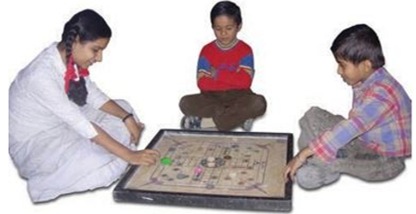  - Friction can be reduced by using  - a) all of these  - b) powder  - c) grease  - d) oil  - Which of the following is not a smooth surface?  - a) Glazed tiles  - b) Surface of tyres  - c) Surface of mirror  - d) Surface of wet soap  - A toy car released with the same initial speed will travel farthest on the  - a) brick surface  - b) muddy surface  - c) polished marble surface  - d) cemented surface  - Friction can be increased by making surface ________.  - The substances which reduce friction are called lubricants. | [5]
2 | Read the text carefully and answer the questions: Step 1 - Tie a string around a brick. Pull the brick by a spring balance. Step 2 - You need to apply some force. Step 3 - Note down the reading on the spring balance when the brick just begins to move. Step 4 - It gives you a measure of the force of friction between the surface of the brick and the floor. Step 5 - Now wrap a piece of polythene around the brick and repeat the activity. 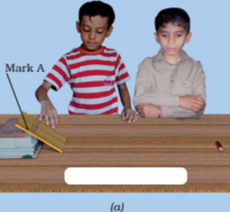  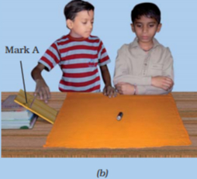  - Friction is  - a) non - contact force  - b) contact force  - c) magnetic force  - d) electrostatic force  - Friction always  - a) Both oppose the motion and helps the motion  - b) none of these  - c) helps the motion  - d) opposes the motion  - Force of friction depends on  - a) smoothness of surface  - b) all of these  - c) inclination of surface  - d) roughness of surface  - ________ is a device used for measuring the force acting on an object.  - Stretching of the spring is measured by a pointer moving on a graduated scale. | [5]
3 | Read the text carefully and answer the questions: Student X is studying about the friction and relate it with some life experiences that of the outer surface of kulhar is greasy, or has a thin layer of cooking oil on it; would it become easier or more difficult to hold. It is difficult to move on a wet muddy track, or wet marble floor. Friction can also produce heat. Vigorously rub your palms together for a few minutes. 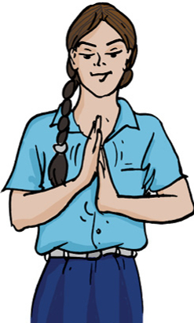  - The sole of the shoes becomes plain after wearing it for several months. The reason is  - a) Wearing out due to no friction  - b) None of the above  - c) Wearing out due to friction  - d) Sole is of bad quality  - Which of the following is responsible for wearing out of bicycle tyres?  - a) Electrostatic force  - b) Muscular force  - c) Magnetic force  - d) Frictional force  - It is very difficult to walk on an oily floor because  - a) Floor gets spoiled  - b) Force of friction is very less  - c) Force of friction is high  - d) There is more resistance  - Rough surfaces produce ________ friction than smooth surfaces.  - Friction can also produce heat. | [5]
4 | Read the text carefully and answer the questions: Step 1 - Take a few pencils which are cylindrical in shape. Step 2 - Place them parallel to each other on a table. Step 3 - Place a thick book over it. Now push the book. You observe the pencils rolling as the book moves. Step 4 - If we use eraser to move the book in this way than to slide it. 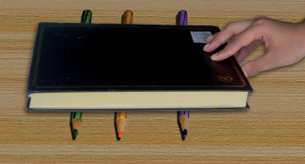  - Sliding friction is ________ than / to rolling friction.  - a) none of these  - b) smaller  - c) greater  - d) equal  - Which of the following produces least friction?  - a) Rolling friction  - b) Static friction  - c) Sliding friction  - d) Composite friction  - When ever the surfaces in contact tend to move or move with respect to each other, the force of friction comes into play  - a) only if the objects are solid.  - b) only if one of the two objects is liquid.  - c) irrespective of whether the objects are solid, liquid or gaseous.  - d) only if one of the two objects is gaseous.  - Sliding friction is ________ than static friction.  - The use of ball bearings between hubs and the axles of ceiling fans is example of rolling Friction. | [5]
5 | Read the text carefully and answer the questions: Student X study about the Friction force. He studied about rolling and sliding friction how to increase or decrease friction, how friction is evil for us and how it is useful. Now he wants to study about fluid friction. As air is very light and thin. Yet it exerts frictional force on objects moving through it. Similarly, water and other liquids exert force of friction when objects move through them.  - The shape of an aeroplane is like a  - a) car  - b) none of these  - c) bird  - d) dog  - Friction due to fluids is called  - a) friction  - b) pressure  - c) drag  - d) force  - Which is a streamlined object?  - a) Boats  - b) Aeroplanes  - c) All of these  - d) Ships  - All objects moving in fluids have streamlined shape to reduce ________.  - The frictional force also depends on the shape of the object and the nature of the fluid. | [5]
 | Section B
6 | Assertion (A): Friction is a self - adjusting force. Reason (R): Friction depend upon the mass of the body.  a) Both A and R are true and R is the correct explanation of A.  b) Both A and R are true but R is not the correct explanation of A.  c) A is true but R is false.  d) A is false but R is true. | [1]
7 | Assertion (A): Friction always opposes the motion. Reason (R): Whenever one surface moves or tries to move over another surface, the force of friction starts acting on the surfaces.  a) Both A and R are true and R is the correct explanation of A.  b) Both A and R are true but R is not the correct explanation of A.  c) A is true but R is false.  d) A is false but R is true. | [1]
8 | Assertion (A): It is convenient to pull the luggage fitted with rollers. Reason (R): Rolling reduces friction.  a) Both A and R are true and R is the correct explanation of A.  b) Both A and R are true but R is not the correct explanation of A.  c) A is true but R is false.  d) A is false but R is true. | [1]
9 | Assertion (A): Spikes are provided in the shoes of players and athletes. Reason (R): It increases friction and prevents slipping.  a) Both A and R are true and R is the correct explanation of A.  b) Both A and R are true but R is not the correct explanation of A.  c) A is true but R is false.  d) A is false but R is true. | [1]
10 | Assertion (A): The objects having streamlined shapes face less friction. Reason (R): Higher the viscosity or thickness of fluid, greater will be the frictional force acting on an object.  a) Both A and R are true and R is the correct explanation of A.  b) Both A and R are true but R is not the correct explanation of A.  c) A is true but R is false.  d) A is false but R is true. | [1]
11 | Assertion (A): When a bicycle is in motion, the force of friction exerted by the ground on the two wheels is always in the forward direction. Reason (R): The frictional force acts only when the bodies are in contact.  a) Both A and R are true and R is the correct explanation of A.  b) Both A and R are true but R is not the correct explanation of A.  c) A is true but R is false.  d) A is false but R is true. | [1]
12 | Assertion (A): Friction is a force which acts in the direction of motion of a body. Reason (R): Polishing a surface reduces friction of the surface.  a) Both A and R are true and R is the correct explanation of A.  b) Both A and R are true but R is not the correct explanation of A.  c) A is true but R is false.  d) A is false but R is true. | [1]
13 | Assertion (A): Friction is caused by irregularities on the surfaces in contact. Reason (R): Friction always opposes the motion of a body.  a) Both A and R are true and R is the correct explanation of A.  b) Both A and R are true but R is not the correct explanation of A.  c) A is true but R is false.  d) A is false but R is true. | [1]
14 | Assertion (A): Two surfaces are rubbed together, first with a small force and then with a greater force. Reason (R): Friction force opposes the relative motion between two surfaces in contact.  a) Both A and R are true and R is the correct explanation of A.  b) Both A and R are true but R is not the correct explanation of A.  c) A is true but R is false.  d) A is false but R is true. | [1]
15 | Assertion (A): Frictional force decreases with the decrease in the roughness. Reason (R): Friction does not causes wastage of energy.  a) Both A and R are true and R is the correct explanation of A.  b) Both A and R are true but R is not the correct explanation of A.  c) A is true but R is false.  d) A is false but R is true. | [1]
 | Section C
16 | State True or False:  - Spring balance is a device to measures the magnitude of force applied.  - Lubricants are used in moving parts of machine to reduce friction.  - Friction always work in the opposite direction of motion of the object.  - Friction produces heat.  - Friction is greater when two surfaces are pressed harder.  - To move an object, applied force is greater than friction.  - Friction causes wear and tear.  - Static friction is more than the sliding friction.  - Treads on the tyres are made to increase friction.  - Sprinkling powder on the carom board reduces friction.  - More streamlined the shape of an object, greater is fluid friction.  - Static friction is less than the rolling friction.  - If there is no friction, a moving object would never stop on its own.  - Higher the speed of the object, more fluid is the friction.  - Magnitude of the fluid friction does not depend on the nature of the fluid.  - Friction is lesser when two surfaces are pressed lightly.  - Sliding friction is less than the rolling friction.  - Rough surface has more friction than smooth surface.  - It is friction which help us to hold things.  - Friction force exerted by the fluid is called drag. | [20]
 | Section D
17 | Fill in the blanks:  - Sliding friction is ________ than the static friction.  - Friction is the force which ________ the relative motion between the two surfaces.  - Friction due to fluid is also called ________.  - All objects moving in fluids have ________ shape to reduce friction.  - Sprinkling of powder on the carrom board________ friction.  - The friction always________the direction of motion.  - Friction produces ________.  - Friction depends on the ________ of surfaces.  - The substances which are used in machines to protect their surfaces from wear caused by friction are called ________.  - Friction opposes the ________ between the surfaces in contact with each other. | [10]
 | Section E
18 | Match the following: 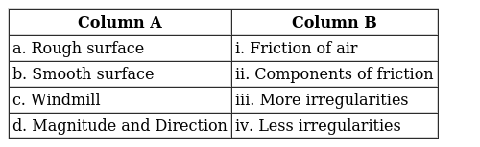 | [2]
19 | Match the following: 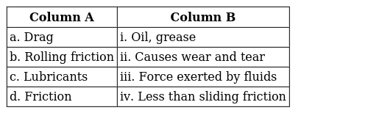 | [2]
20 | Match the items given A with those in Column B suitably: 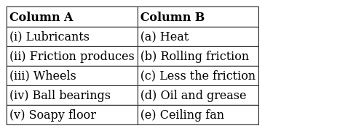 | [2]
21 | Match the following: 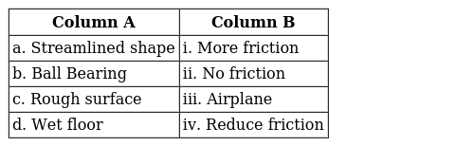 | [2]
22 | Match the following: 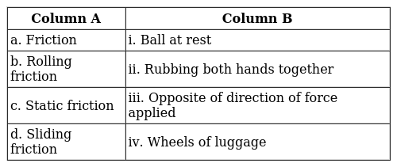 | [2]
 | Section F
23 | State advantages and disadvantages of fluid friction? | [4]
24 | What are lubricants? How can we reduce friction? | [4]
25 | Explain why rolling friction less than sliding friction? | [4]
26 | The tyres of automobiles are made corrugated and rough. Why? | [4]
27 | - When you play a game of carom, what do you do to make the coins move smoothly on the board?  - If you try to hold a glass with soapy hands, it can easily slip from your hands. Why? | [4]

